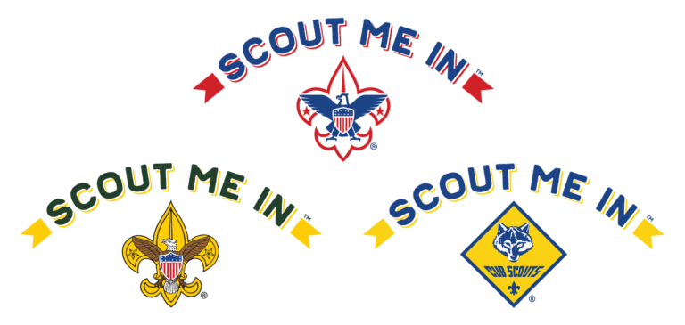
FIRST ANNUAL POMPERAUG DISTRICT
MINI-GOLF TOURNAMENT FUNDRAISER SPONSORSHIP FORM

Where: Sports Center of Connecticut
784 River Road, Shelton CT

When: Saturday, May 11 9AM-Noon

For more information and to register or Sponsor visit: https://www.ctyankee.org/district/pomperaug/pomperaug-mini-golf-fundraiser/

Name/Organization: ______________________________________________
 | $100 | Hole Sponsor
 | $500 | Longest Drive Sponsor
 | $500 | Closest to the Pin Sponsor
 | $500 | Drink Sponsor
 | $500 | Food Sponsor
 | $1000 | Tournament Sponsor

Referred By:_______________________________________________

Mail Form with payment to: CT Yankee Council, P.O. Box 32, Milford, CT 06460-0032

