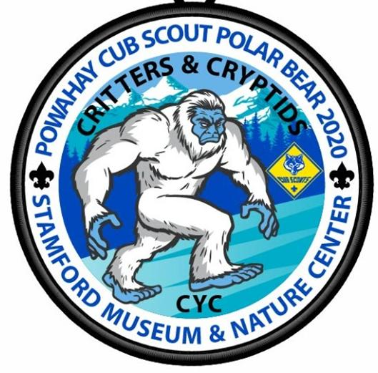

Join us at the Stamford Museum and Nature Center for a Cub Scout Polar Bear with a fun “Critters & Cryptids” program.

Cryptids are creatures whose existence is based on alleged sightings and recordings. Cryptozoology is the study of cryptids to analyze in a scientific fashion. Join us for a winter day of fun as Scouts become “Cryptozoologist” to study these mystical creatures as well “critters” that really do exist.

**Eight Action Stations**

**Both Indoor and Outdoor Stations**

1. **Cryptozoology:** Real or Reality — While existence of the Yeti and Loch Ness Monster are still unknown, there are many animals like the giant squid and okapi that really do exist. Test your knowledge in our Real or Reality cryptid trivia.
2. **Fabulous Furbearers**- Discover the largest mammals that really live in CT- black bear, moose, deer, and coyote—in this hands-on artifact lab.
3. **Magical Beasts and Where to Find them**: Discover some real-life magical beasts up close and personal!
4. **Oh Yeti!:** A twist on the game Oh Deer!, Oh Yeti! Will give some chances to run while learning about how predator-prey relationships work and what the carrying capacity of an area is. Outdoor Station
5. **Planetarium -- Animals in the Sky**: Discover the stories behind some of the common constellations in our sky and what time of year we can see them.
6. **Heckscher WILD! self-exploration**: 20 minutes of self-exploration in our Heckscher WILD! exhibit. Exhibit will be staffed but there would be no formal program.
7. **A Life in the Wild by Thomas D. Mangelsen photo exhibition**. Mangelsen has spent over 40 years filming and photographing nature and wildlife from all over the world. A Life in the Wild is an exhibition containing 40 of Mangelsen’s most resonant images.
8. **Yeti Challenge – Leave No Trace**… Big Foot (Yeti) has been doing it for year! A District run station featuring the Yeti. We’ll take Scouts through the Cub Scout the requirements for the “Leave No Trace Awareness Award”. Plus learn about upcoming Scouting activities and programs.

Powahay District

Connecticut Yankee Council

Cub Scout Polar Bear

“Critters & Cryptids”

**Saturday,**

**February 1, 2020**

9:30 AM to 3 PM

**$15/Youth and $12/Adult**

**Stamford Museum**

**& Nature Center**

151 Scofieldtown Road,

Stamford CT 06903

**My Best Friend Is A Scout!**

____________________________________________

(Inviting Cub Scout's Name)

**Invites You to the Cub Scout Polar Bear**

See details below

Come join the fun with your friends in Cub Scouts!

Please RSVP to:

Pack Contact Name: ____________________________

Email: ________________________________________

Phone: _______________________________________

By (Date):_____________________________________

Dear Parents,

The child on this invitation is a friend of your child, and a Cub Scout, and has personally invited your child to join them at this SPECIAL Cub Scout Event. In Cub Scouts, children have lots of fun, learn new things and make new friends. But Cub Scouts is much more than that, it is fun - with a purpose. Everything they will do in Cub Scouts - ceremonies, earn awards, sports, games and crafts, will be done with a specific purpose in mind. Take a look at the 12 Core Values Cub Scouting.

Citizenship, Honesty, Compassion, Perseverance, Cooperation, Positive Attitude, Courage, Resourcefulness, Faith, Respect, Health and Fitness Responsibility.

Please come join us at our event and see what all the fun is all about!