AND READ!

Before you start your unit’s recharter process, please read and make sure you follow the steps below:

- Be sure that all leaders are trained in their current position. You can use my.Scouting.org training manager for this. All leaders must be trained in EVERY position they are registered for. If Training Manager lists them as not trained and you believe they are, please contact Karen Caiati at karen.caiati@scouting.org. If they are not trained, before you proceed, have them complete the proper training at my.Scouting.org.
- Be sure that you have a new signed Additional Disclosures and Background Check Authorization form from each registered adult. Please collect these as a unit and turn in with your recharter.
- Be sure that all youth and leaders show as registered in your unit. Again, my.Scouting.org will show you every adult and youth currently registered in your unit. If they are not listed there, they are NOT registered in your unit. If not, you must submit an application to the Council Resource Center to ensure they are registered with your unit.
- If you choose to utilize the on-line Charter Organization Approval process, be sure that your Executive Officer or Chartered Organization Representative has access to the on-line charter renewal system to approve your charter. If not, you can print a final roster for signatures at the end of the on-line process. Remember, if you do the on-line approval and go back to make changes, you will have to complete the on-line approval process again.
- After selecting submit to Council and printing the final version, if you see the following, your charter has been approved on-line and submitted:
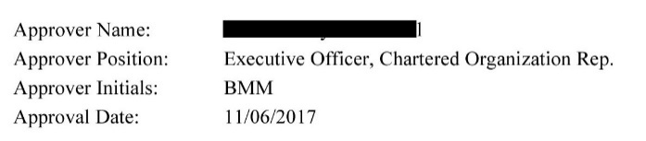
- After selecting submit to Council and printing the final version if you see the following, your charter must be signed by either the Executive Officer or Chartered Organization Representative AND the unit leader and mailed or emailed in to Council:
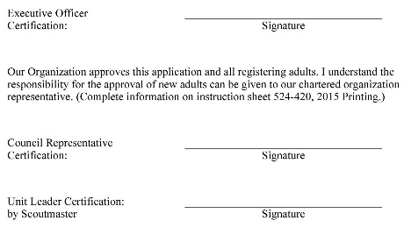
- To avoid overpayment, paying on-line is strongly discouraged! If you pay the registration fee on-line during the charter process, you will NOT be eligible for any refunds! In addition, a 3% surcharge is added to the on-line charter renewal payment. We encourage you to have a blank check with you at Recharter Day and after your charter is reviewed, you will be given the total amount due. This amount will be deposited in your unit account until your charter is processed and only the necessary amount will be deducted. Following are a couple reasons the amount due might be different from the original amount stated: a) adult leaders cannot be processed due to lack of training or b) members registered in multiple positions (i.e., Assistant Scoutmaster in Troop and Den Leader in Pack or youth member registered in both Boy Scout Troop and Venturing Crew).

