CUB SCOUT DAY CAMP
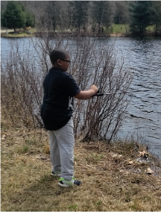
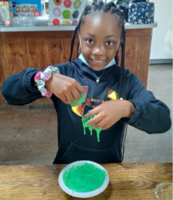
JOURNEY INTO Leadership & STEM
At Deer Lake Scout Camp

Open to youth ages 6 – 12.
Transportation, Breakfast, and lunch will be provided.
Monday - Friday ● 9:00 am - 3:00 pm
Bus location - Hill Central: Drop off: 7:45am ● Pick up: 4:00pm
FREE FOR - NHPS youth and Residents will have Scholarships
** Children must have a current physical with a medication plan form. **

Camper’s Name
Camper’s age Camper’s school
Date of Birth
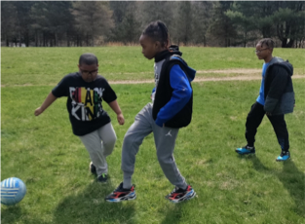
T-Shirt Size: Small Medium Large X-Large
Adult Small Adult Medium
Parent’s Name
Parent’s Address
Parent’s Email
Parent’s Phone Number
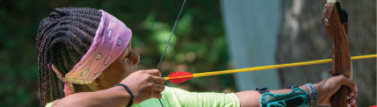

Please check the weeks your camper will attend:
Week 1: July 5 – July 8, 2022
Week 2: July 11– July 15, 2022
Week 3: July 18– July 22, 2022
Week 4: July 25– July 29, 2022
**Please be advised, we are a peanut-free site. **

