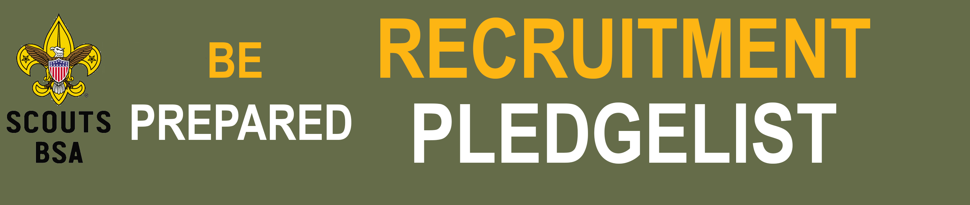

Troop |  | Fall Recruitment Information

Scoutmaster: |  | Phone: |  | Email:

Committee Chair: |  | Phone: |  | Email:

Membership Coordinator: |  | Phone: |  | Email:

Our goal is to Recruit new Scouts for our Troop. Remember a 10% increase in membership earns you free test site at a council camp.

Our troop has a membership plan! We would like to share it with the council.

We love Scouting but we would like some help in developing a successful membership plan.

Date of our 1st Troop Open House: |  | Time: |  | Location:

Date of our 2nd Troop Open House: |  | Time: |  | Location:

We will do the following to promote our troop and recruit new Scouts and Families.
A successful Membership Plan will have at least Six of items:

Create an engaging flyer to promote your Scouts BSA Troop (Council office will even make it for you)
Setup a booth or table at back to school night or similar events to interact with parents and distribute flyers directly to interested families
Have scouts invite friends to Join your Troop. Consider having them writing letters to friends and using a recruiter strip incentive
Promote your events on Social media like Facebook and Instagram. The council will even pay to boost your event for you.
Place Yard Signs around your local schools announcing upcoming Open House to attract the attention of parent and perspective members. You can get these free of charge from the council office
Host 2 Open House or Community events
Share your flyers with local churches, libraries, and community websites, calendars, and bulletins to reach a broader audience
Distribute flyers (Physically or Digitally) at your local school
Call or email families who showed interest at an open house or other marketing event
Update your BeAScout pin and follow up on all leads
Help your local Cub Scout Pack with one of their events

Request Recruitment Materials from the Council Office:

Print Flyers. Number of copies: If you would like the council to print your flyers let us know the date, time and location of your Join Night and a contact person
Request program materials including: Base Camp Pop up and inflatable GaGa Pit. Request these materials at https://mycouncil.ctyankee.org/Property/CouncilServiceCenter
Request a boost to on Social Media to your Join Event.

