2026
TRAILBLAZER CUB SCOUT PACK PLAN


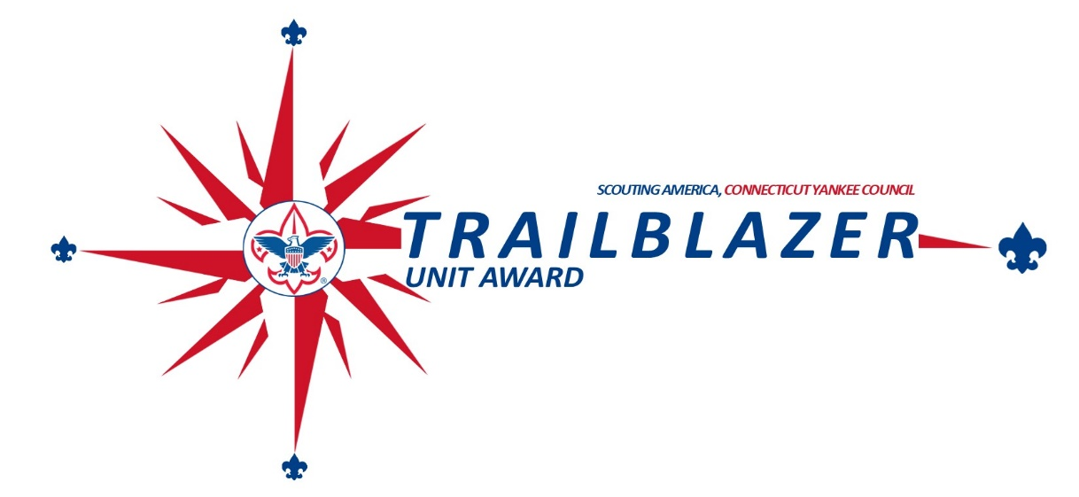
Notes


Trailblazer Cub Scout Unit Success Guide (2026)
Pack of District

Item | Objective | Bronze Level | Silver Level | Gold Level | Bronze  Points | Silver  Points | Gold  Points
Item | Planning, Budgeting, & Funding |  | Total Points: 400
1 | Annual Planning: Conduct annual planning conference to  plan out the annual calendar and budget | Conduct an annual planning conference and develop annual calendar and budget | Conduct annual planning conference using school calendar | Silver plus use  previous year’s  budget and actuals to develop budget | 50 | 100 | 200
2 | Fundraising: Conduct unit fundraising to support quality unit program and support a Scout is thrifty goal | Conduct at least 1 unit fundraiser | Sign up for the  Council unit product sale and sell an average of $50 per Scout | Sell an average of  $100 per Scout in Council product sales | 25 | 50 | 100
3 | Stewardship Society: The unit conducts a Stewardship Society presentation for its leaders and families. | Conduct a Stewardship Society presentation by the end of April | Conduct a Society presentation by the end of March | Conduct a Society presentation by the end of February | 25 | 50 | 100
 | Membership |  | Total Points: 500
4 | Membership Growth: support membership growth in your unit and serve more youth with our life-changing program. | Hold a join event before Oct. 31 and have an updated beascout.org pin | Bronze plus start a new Lion or Tiger den with at least 3 Scouts | Start a new Lion and Tiger den or have at least 6 Scouts in an  existing Tiger den | 50 | 100 | 200
5 | Retention & Engagement: Support membership retention and retain and significant portion of unit membership | Complete Bobcat adventure for all dens in first 30 days of  scout year | Bronze plus have a 75% retention rate | Silver plus 50% of families volunteer in the unit | 50 | 100 | 200
6 | Arrow of Light to Scout Transition: Plan and execute a transition plan for AOL Scouts from the Pack to a Troop | All AOL Scouts visit at least 1 troop | Bronze plus 50% of Arrow of Light  cross over to a troop | Bronze plus 75% of Arrow of Light cross over to a troop | 25 | 50 | 100
 | Program |  | Total Points: 600
7 | Advancement: Achieve a high percentage of Rank Advancement | 90% of Scouts earn Bobcat Adventure by Dec 31st | Bronze plus 80% of Scouts earn 12 adventures by Dec. 31st. | Silver plus 75% of Scouts earn rank advancement by May 31st | 100 | 200 | 300
8 | Outdoor Activities: Hold outdoor events and camp outs for your unit | Have 1 BALOO trained leader for every 20 Scouts | Bronze plus hold at least 2 outdoor events with 60% attendance | Silver plus hold at least 5 outdoor  events with 60% attendance one of which is an overnight | 50 | 100 | 200
9 | Service Projects: Support your community through service projects | Complete at least 1 service project | Average 30 minutes of service  per scout | Silver plus 50% service project  attendance | 25 | 50 | 100
 | Volunteer Leadership |  | Total Points: 500
10 | Leadership Recruitment and Succession planning: Develop a plan to recruit and replace unit volunteers | Share a Pack task list with all families | Bronze plus all den leaders recruited by Oct 31 | Silver plus a succession plan in place for Cubmaster and Committee Chair plus at least 1 new registered  volunteer recruited | 50 | 100 | 200
11 | Trained Leadership: Have trained and engaged leaders. All leaders MUST complete Youth  Protection Training | Cubmaster and Committee Chair position trained | Bronze plus all den leaders position trained | All registered leaders position trained | 50 | 100 | 200
12 | Mentorship Performance: Participate in the Council Unit Mentorship Program | Be a mentor unit or mentee unit | Work with mentor or mentee units on recruitment or calendar planning | Work with mentor or mentee unit for 3 events, join night help and leadership recruitment support | 25 | 50 | 100
Bonus | Webelos Resident Camp | Send at least 2 Scouts to Webelos Resident Camp at Camp Sequassen |  |  | 50
Bonus | Scouting Stewardship Society | At least 5-unit parents or leaders of the unit are current Society members |  |  | 50

Total Score: # of Categories with Points: __________

Level Earned:
Gold (1,200+ points, 8+ Categories with  points) | Silver (850+ points, 8+ Categories with  points)
Bronze (525+ points, 7+ Categories with  points) | Participant

Table of Contents
- Program Overview & Recognition 4
- Timeline 5
- How to Use This Guide 5
- Annual Planning, Budgeting & Funding 6
- Growing Membership 6
- Retention & Engagement 6
- Advancement & Program Delivery 6
- Outdoor Activities & Camping 8
- Service Projects 8
- AOL to Scouts BSA Transition 9
- Leadership Recruitment and Succession planning 9
- Trained Leadership 9
- Mentorship Program (CYC-Specific) 9

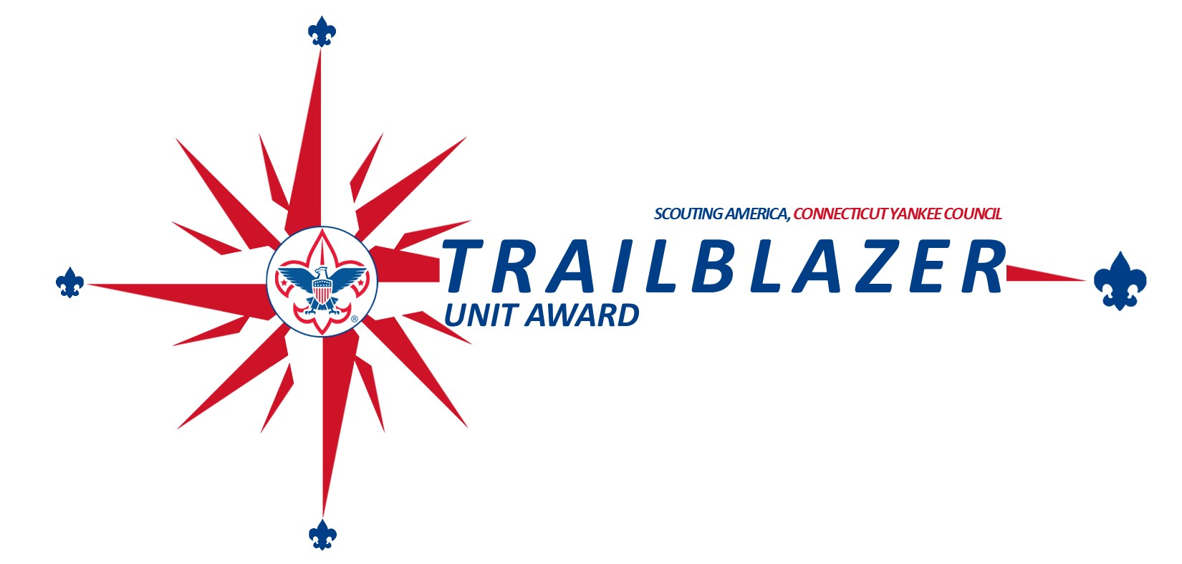

Program Overview & Recognition

Purpose:

The Connecticut Yankee Council (CYC) Trailblazer Unit Success Program is a strategic, performance-based framework designed to help Cub Scout Packs deliver excellent, consistent, and sustainable programming. It blends the best of BSA's Journey to Excellence (JTE) model with local CYC priorities to reward well-rounded, high-impact units.

Performance Tiers:

Recognition Level | Points Required | Objectives Required
Bronze | 525+ | At least 7
Silver | 850+ | At least 8
Gold | 1100+ | At least 8 (including Bronze in Outdoor Activities)

Rewards

To encourage participation in this program the council is offering incentives for all levels a unit achieves. For a unit to receive the bronze, silver and gold levels unit must complete its unit renewal no later than December 31st. Recognition will be given to units by their district in February. The rewards for this program include:
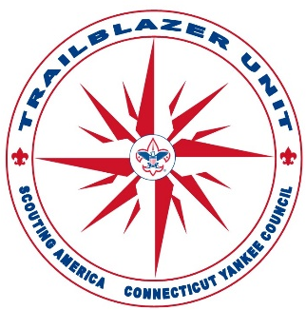
Level | Points Required | Categories With Points | Incentive
Participation | N/A | N/A | Recognition Ribbon
Bronze | 525+ | 7+ | plus, Free weekend tent site at council camp
Silver | 850+ | 8+ | plus, your unit can attend Extreme Scouting
Gold | 1100+ | 8+ (with Bronze in Outdoor Activities) | plus 1% extra  commission for council product sales or 15% discount for Day Camp and Webelos Resident Camp
Gold + 10% Unit Growth | 1100+ | 8+ (with Bronze in Outdoor Activities) | Gold + Free pinewood derby cars for all youth in pack

Timeline

By Date | Task
January 15 | Last day to turn in Trailblazer Unit Success Scorecard to District Executive to be eligible for incentives
May-July | Conduct Annual Planning conference, review Trailblazer Unit Success program, and ensure annual plan aligns with Trailblazer Unit Success Program
September | Review Plan and adjust to ensure success
November | Complete unit renewal process and complete Trailblazer Unit Success Program and turn into council
December 31 | Last day to complete unit renewal to be eligible for Trailblazer Unit Success Incentives

How to Use This Guide

Who Should Use This:

Role | Responsibilities
Cubmaster | Oversees program delivery
Committee Chair | Governance, administration
Chartered Org Rep | Liaison to chartered organization
Den Leaders | Lead weekly den meetings and advancement
Committee Members | Support roles: advancement, fundraising, events
Commissioners | Coaching and unit health support

Planning Timeline:

Month | Key Actions
May–June | Year-end review + Planning Session
May-July | Budget and calendar finalized
August | Join Event + Orientation
Sept–Oct | Leader training + Den startup + Service Project
Nov–Dec | Advancement tracking + Crossover planning
Jan–Feb | Mid-year review + Commissioner check-in
March–April | Camp sign-ups + Succession Planning
May | Submit scorecard + Celebrate progress

Annual Planning, Budgeting, & Funding

Planning Checklist:

Step | Description
Gather | Calendars (school, district), budget history, council events
Plan | Conduct a Pack Planning Conference with key leaders
Brainstorm | Build a list of ideal events, rank them by interest and feasibility
Finalize | Assign dates, costs, and responsibilities; publish calendar
Budget | Estimate costs for awards, camp, activities, supplies
Fundraising  Presentation | Link Unit product sale goals to budget
Fundraising  Presentation | Work with District team to schedule Stewardship Society presentation

Growing Membership

Membership Milestones:

Growing your unit’s membership is one of the most important things you can do to ensure your units health. The council has put together many resources to help you grow your unit. These resources can be found at https://www.ctyankee.org/membership

Retention & Engagement

Having a strong and fun program in your unit is the most important thing you can do to increase the retention rate. Focus on the program area of the success guide and retention will follow.

Engagement Tracker:

Metric | Target
Retention Rate | 75%+
Bobcat Completion (new Scouts) | Within 30 days
Family Volunteer Participation | 50% (for Gold level)
Monthly Pack Activities (non-meeting) | 1+

Advancement & Program Delivery

Track Progress Regularly

    - Use tools like Scout book or spreadsheets to monitor each Scout’s advancement.

    - Share progress reports with parents and den leaders monthly.

Plan the Program Around Advancement

    - Build your pack and den calendars to naturally cover the required adventures.

    - Include rank-required activities in den meetings and campouts.

    - Use a checklist to ensure all adventures are scheduled throughout the year.

Engage Parents Effectively

    - Educate families early on how advancement works and what is expected at home.

    - Encourage parents to help with elective or home-based requirements.

    - Hold family advancement nights or “catch-up” sessions.

Train and Support Den Leaders

    - Make sure leaders understand the advancement requirements.

    - Provide leaders with planning tools and shared lesson plans.

    - Host leader roundtables or mentorship from experienced leaders.

Set Clear Goals

    - Set realistic goals like “80% of Wolves complete rank by April.”

    - Recognize progress and celebrate achievements — create a culture of advancement success.

Use Pack Events Strategically

    - Include advancement opportunities in pack hikes, service projects, or day camps.

    - Invite guest speakers or local experts to help with adventure requirements.

Recognize Advancement Promptly

    - Give awards as soon as they’re earned, not months later.

    - Hold monthly recognition ceremonies to keep motivation high.

    - Use advancement ceremonies to make Scouts proud of progress.

Outdoor Activities & Camping
Outdoor activities will keep your Scouts engaged in the pack’s program. Outdoor activities do not need to be elaborate to be effective. These activities can be as simple as a hike on a local trail or a field day competition.
Camping is a great way to engage with the outdoors. If your pack wants to hold a camping event it is best to stay local. The closer you are to home the more likely your families will attend. Look for Council-approved locations to have your campout.

The council also offers several camping programs throughout the year which you can use to hold a camping program without having to put a lot of planning into these events. Some of the camping opportunities include Scout Day at Lime Rock Park, Cub Scout Safari, Sr. Cub Outdoor Readiness Event, CONNJAM, and district camporees. To find out more about these outdoor activities and camping opportunities look on the council calendar at https://www.ctyankee.org/calendar/https://www.ctyankee.org/calendar/

Service Projects
Service projects are another key part of our program that will instill a sense of helping others in your Scouts.
Service projects do not need to be a complicated project to be effective. Helping with your chartered
organization or another local organization is a great way to begin. You could also clean up a local trail. If you are looking for an indoor activity there are many organizations that take handmade cards for the elderly or
soldiers.

Service is part of the advancement programs for higher ranks, so having service projects lined up is essential for your unit to advance its Scouts. Except for Eagle, the service projects do not need to be planned out by the Scouts and could be done in conjunction with other organizations.
Ideas:

- Park cleanups
- Scouting for Food
- Veteran ceremonies or parades
- Helping your Chartered Organization

To count towards your Trailblazer Unit Success Points, you will need to log the service hours in Scout book. The steps to complete this logging are:

- Login to Scout book Plus: My.scouting.org is the primary platform for logging service hours and can be accessed at https://advancements.scouting.org/.
- Click Activity Log on Left hand Side.
- Click + New Activity Log and select Service hours.
- Select date of Service Project
- Click + Create New Activity
- Enter Service Project information.
- Click Record and Finish

AOL to Scouts BSA Transition
Creating a relationship with local troops is the best thing you can do to increase your Scout’s chances of moving onto a troop. This could mean that you do joint events or have den chief helping your unit. However, at a minimum you should be in communication with local troops to make sure that all your Scouts visit them so they can decide which unit is right for them. If you do not know which troops are near your community, touch base with your district leadership and they can get you in touch with the units. You can find your district leadership by checking the district websites at https://www.ctyankee.org/districts/.

Leadership Recruitment and Succession planning
Your unit cannot function without volunteer leadership. Just like your unit should always be recruiting Scouts, they must also be recruiting adult volunteers. We have included strategies on how to recruit adults within our recruitment guides which can be found at https://www.ctyankee.org/membership.

Trained Leadership
Having trained leader is important step in having safe and effective den and pack meetings as well as to help you with general pack administration. All your volunteers need to complete youth protection training and position specific training, both of which can be taken online at my.scouting.org. For more advanced training there is Basic Adult Leader Outdoor Orientation (BALOO) which will give you all the camping skills you need to succeed on a campout (A BALOO trained leader is required be at all campouts). For more advanced leadership training you should also consider Wood Badge. Information about both advanced trainings can be found at https://www.ctyankee.org/training-basecamp.

Mentorship Program (CYC-Specific)

The unit mentorship program is a new program at the CT Yankee council where a strong unit partners with a unit that is struggling to help them get better in areas they are struggling with. This program is a structured program offering the units the opportunity to work together to make each other stronger. If you are interested in participating in this program, you can find out more information at https://www.ctyankee.org/membership

