2026
TRAILBLAZER SCOUTS BSA TROOP PLAN

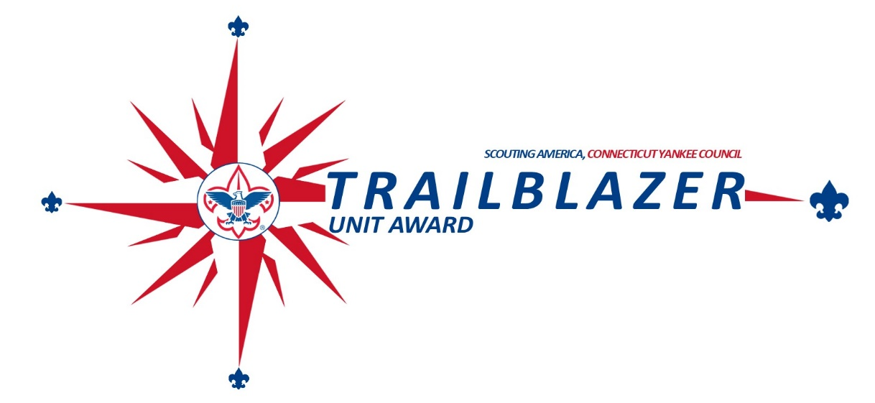
NOTES


Trailblazer Scouts BSA Unit Success Guide (2026) Troop _______ of _________________District

Item | Objective | Bronze Level |  | Silver Level |  |  | Gold Level | Bronze  Points | Silver  Points | Gold  Points
Item | Planning, Budgeting, & Funding Total Points: 400
1 | Annual Planning: Conduct annual planning conference to plan out the annual calendar and budget | Conduct an annual planning conference with the PCL integrating the District and Council  Calendar |  | Bronze plus create an annual budget |  |  | Silver plus identify funding gaps and create a fundraising plan | 50 | 100 | 200
2 | Fundraising: Conduct unit fundraising | Conduct at least 1 unit fundraiser |  | Sign up for the  Council unit product sale and sell an average of $50 per Scout |  |  | Sell an average of  $100 per Scout in Council product sales | 25 | 50 | 100
3 | Stewardship Society: The unit conducts a Stewardship Society presentation for its leaders and families. | Conduct a Stewardship Society presentation by the end of April |  | Conduct a Society presentation by the end of March |  |  | Conduct a Society presentation by the end of February | 25 | 50 | 100
 | Membership |  |  |  |  | Total Points:500
3 | Membership Growth:  support membership growth in your unit | Hold a recruitment event and update beascout.org pin |  | Bronze plus grow membership by 3% |  |  | Bronze plus grow membership by 5% | 50 | 100 | 200
4 | Retention & Engagement: Support membership retention and retain and significant portion of unit membership | 75% of first year Scouts attend summer camp |  | 75% of all Scouts attend summer camp |  |  | Re-register 85% of eligible Scouts | 50 | 100 | 200
5 | Arrow of Light to Scout Transition: Plan and execute transitioned Scouts from a Pack to the Troop | Hold 1 joint event with AOL den |  | Hold 2 joint events with AOL den and attend cross over ceremony |  |  | Hold 3 joint events with AOL den and attend cross over ceremony and have an assigned den chief | 25 | 50 | 100
 | Program |  |  |  |  | Total Points: 600
6 | Advancement: Achieve a high percentage of Rank  Advancement | 40% of Scouts earn at least one rank in the  calendar year |  | 60% of Scouts earn at least one rank in the  calendar year |  |  | 80% of Scouts earn at least one rank in the calendar year | 100 | 200 | 300
7 | Camping: Hold outdoor events and camp outs for your unit | Hold 4 campouts and attend summer camp |  | Hold 6 campouts and attend summer camp |  |  | Hold 9 campouts and attend summer camp plus plan a long-term trip or high adventure experience | 50 | 100 | 200
8 | Service Projects: Support your community through service projects | Complete at least 1 service project and  average 3 hours of service per scout |  | Complete at least 1 service project and  average 4 hours of service per scout |  |  | Complete at least 1 service project and average 5 hours of service per scout | 25 | 50 | 100
 | Volunteer Leadership |  |  |  |  | Total Points: 500
9 | Youth Leadership and Troop Governance: Have a functioning youth leadership program and offer youth leadership training | Hold at least 3 PLCs in calendar year and complete a youth led annual planning conference |  | Hold at least 4 PLCs in calendar year and complete a youth led annual planning conference and 50% of  leaders complete ILST |  |  | Hold at least 6 PLCs in calendar year and complete a youth led annual planning conference and 75% of leaders complete ILST | 25 | 50 | 100
10 | Trained Adult Leadership: Have trained and engaged leaders. All leaders MUST complete Youth Protection Training | Scoutmaster and  Committee Chair position trained |  | Bronze plus 50% of adult leaders are position trained |  |  | Silver plus 75% of adult leaders are position trained | 50 | 100 | 200
11 | Mentorship Performance: Participate in the Council Unit Mentorship Program | Assist New or Restarting Troop |  | Bronze plus Plan or Attend Joint Campout/Event |  |  | Silver plus assist with youth or adult recruitment | 25 | 50 | 100
Bonus | Summer Camp | Send at least 3 youth to Camp Sequassen for summer camp |  |  |  |  |  | 50
Bonus | Scouting Stewardship Society | At least 5-unit parents or leaders of the unit are current Society members |  |  |  |  |  | 50

Total Score: # of Categories with Points: _________

Level Earned:
Gold (1,200+ points, 8+ Categories with points) | Silver (850+ points, 8+ Categories with points)
Bronze (525+ points, 7+ Categories with points) | Participant

Table of Contents
- Program Overview & Recognition 3
- Timeline 4
- How to Use This Guide 4
- Annual Program Planning & Budgeting 5
- Membership Growth 5
- Retention & Engagement 5
- Advancement 6
- Camping & Outdoor Adventure 7
- Service & Citizenship 8
- AOL to Scout Transition Support 8
- Youth Leadership & Troop Governance 9
- Adult Leadership Development 9
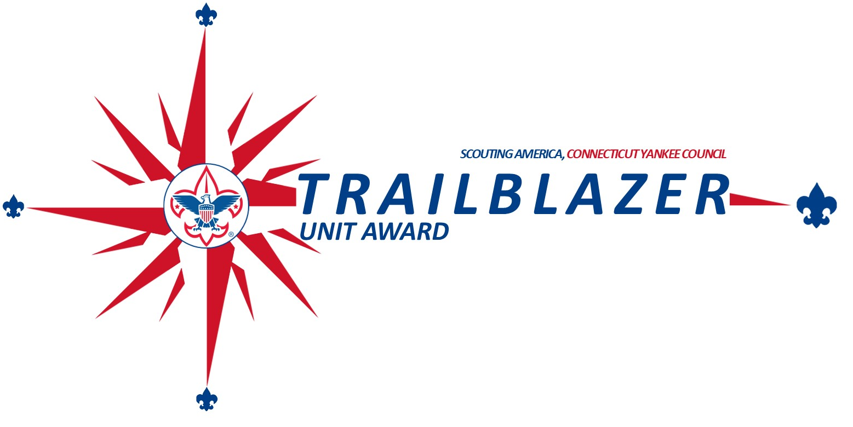
- Mentorship Program (CYC-Specific) 9

Program Overview & Recognition

Purpose

The Connecticut Yankee Council (CYC) Troop Success Program supports Scouts BSA units with a performance-based framework built on Journey to Excellence (JTE). This guide empowers troops to create a high-impact, youth-led program and earn recognition for excellence.

Recognition Tiers

Level | Points Required | Categories With Points
Bronze | 525+ | 7+
Silver | 850+ | 8+
Gold | 1200+ | 8+ (with Bronze in Camping)

Rewards

To encourage participation in this program, the council is offering incentives for all levels a unit achieves. For a unit to receive the bronze, silver and gold levels, a unit must complete its unit renewal no later than December 31st. Recognition will be given to units by their district in February. The rewards for this program include:

Level | Points Required | Categories With Points | Incentive
Participation | N/A | N/A | Recognition Ribbon
Bronze | 525+ | 7+ | Participant incentive plus Free weekend tent site at council camp
Silver | 850+ | 8+ | Bronze incentive plus unit youth can attend Extreme Scouting or an additional tent site weekend, Patches for all unit
Gold | 1200+ | 8+ (with Bronze in Camping) | Silver plus 15% off Camp Sequassen Summer Camp and NYLT Fees
Gold + 10% Unit Growth | 1200+ | 8+ (with Bronze in Camping) | Gold + Free cabin or range at a council camp

TIMELINE

By Date | Task
January 15 | Last Day to Turn in Unit Success Scorecard to District Executive to be eligible for incentives
July | Conduct Annual Planning conference, review unit success program, and ensure annual plan aligns with Unit Success Program
September | Review Plan and adjust to ensure success
November | Complete Unit renewal process and complete Unit Success Program and turn into council
December 31 | Last day to complete unit renewal to be eligible for Unit Success Incentives

How to Use This Guide

Who Should Use This:

Role | Responsibilities
Scoutmaster | Lead program implementation
Committee Chair | Governance, finances, chartered organization liaison
SPL & PLC | Youth leadership and program planning
Committee Members | Advancement, outdoor, fundraising, communications
Commissioners | Unit coaching and health monitoring

Planning Timeline

Month | Key Milestones
May–June | Annual Planning Conference (with PLC)
July | Finalize calendar and budget
August-Sept | Fall recruitment + Troop Open House
Sept–Oct | Conduct training; run fall outdoor program
Nov–Dec | Advancement focus + service projects
Jan–Feb | Recharter support and mid-year check-in
March–April | Summer camp prep + leadership elections
May | Submit Trailblazer scorecard + awards planning
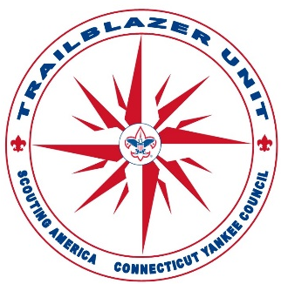

Annual Program Planning, Budgeting & Funding

Planning Milestone | Responsible Party | Due By
Annual Program Plan | PLC + SM + CC | July
Budget Finalization | Treasurer + Committee | July
Fundraising Goals | Fundraising Chair | August
Calendar Distribution | SPL + Secretary | August
Stewardship Society Presentation | CC + Committee | December

Steps:

  - Conduct a PLC-led brainstorm of activities and goals.
  - Integrate district and council events.
  - Use Troop Budget Planner to match events with expenses.
  - Identify funding gaps and create fundraising plan (product sales, donations)
  - Communicate final plans to all families and leaders.

Membership Growth

Growing your unit’s membership is one of the most important things you can do to ensure your units health. The council has put together many resources to help you grow your unit. These resources can be found at https://www.ctyankee.org/membership

Tips:

  - Host a Troop Open House with hands-on demonstrations.
  - Engage with local Packs and AOL dens.
  - Assign a youth-led welcoming committee.

Retention & Engagement

Having a strong and fun program in your unit is the most important thing you can do to increase the retention rate. Focus on the program area of the success guide and retention will follow.
Strategies:

  - Schedule regular patrol outings and service
  - Host parent orientation nights and troop-family events.
  - Use Scoutmaster conferences as retention touchpoints.

Advancement

Incorporate Advancement into Every Meeting and Outing

  - Include rank requirements and merit badge skills in your weekly meetings and campouts.

  - Make advancement a natural part of activities, not a separate track.

Example: Use a campout to cover requirements like fire building, knots, or cooking.

Use Individual Scout Advancement Conferences

  - Conduct regular Scoutmaster conferences — not just before a Board of Review.

  - Schedule periodic check-ins with each Scout to help set goals and troubleshoot delays.

Track Progress and Set Troop-Wide Goals

  - Use tools like Scoutbook, Troop Web Host, Troop Track, or Troop Master to track advancement.

  - Set realistic, visible goals like “70% of Scouts advance one rank per year.”

  - Share troop-wide progress with youth leaders and parents.

Make Campouts Count

  - Plan purposeful campouts that target rank requirements.

  - Assign a few specific skills per trip (e.g., Orienteering, Cooking, First Aid).

  - Use patrol competitions to encourage skill development.

Empower Youth Leaders to Teach

  - Let older Scouts teach younger ones — this fulfills leadership requirements and reinforces skills.

  - Encourage the Troop Guide and Instructors to plan advancement sessions for new Scouts.

Hold Advancement Workshops

  - Run periodic workshops (Saturday mornings or overnights) focused on Tenderfoot–First Class skills.

  - Offer Merit Badge days or monthly clinics to cover badges not easily done at home.

Educate and Involve Parents (But Don’t Let Them Run It)

  - Provide parents with advancement info so they can encourage and support but not interfere with the youth-led process.

  - Hold parent orientation sessions to explain how ranks, merit badges, and Boards of Review work.

Make Boards of Review Happen Promptly

  - Avoid delays after Scoutmaster conferences.

  - Schedule monthly or bimonthly Boards of Review so advancement doesn’t stall.

  - Train a group of committee members to be available regularly.

Recognize Advancement Publicly

  - Hold advancement ceremonies at Courts of Honor or monthly meetings.

  - Celebrate every rank and badge. Recognition motivates others.

Guide, Don’t Push

  - Advancement is not a race — emphasize learning and character development.

  - Support Scouts in setting their own goals and pacing, especially in middle and high school years.

Camping & Outdoor Adventure

Outdoor activities will keep your Scouts engaged in the troop program. Outdoor activities do not need to be elaborated to be effective. These activities can be as simple as camping out in your town park.

Camping is a great way to engage with the outdoors, work on advancement, and have the adventure of a lifetime. The council also offers several camping programs throughout the year which you can use to hold a camping program without having to put a lot of planning into these events. Some of the camping opportunities include Scout Day at Lime Rock Park, District Spring and Fall Camporees, Klondike Derby, CONNJAM, and district camporees. To find out more about these camping opportunities look on the council calendar at https://www.ctyankee.org/calendar/https://www.ctyankee.org/calendar/. You can also ask other units places that have enjoyed camping to add new places into your camping routine.

Service & Citizenship
Service projects are another key part of our program that will instill a sense of helping others in your Scouts. Service projects do not need complicated projects to be effective. Helping with your chartered organization or another local organization is a great way to begin. You could also clean up the local trail. If you are looking for an indoor activity, there are many organizations that take handmade cards for the elderly or soldiers.

Service is part of the advancement programs for higher ranks, so having service projects lined up is essential for your unit to advance its Scouts. Except for Eagle, the service projects do not need to be planned by the Scouts and could be done in conjunction with other organizations.

Ideas:

  - Park cleanups
  - Scouting for Food
  - Veteran ceremonies or parades
  - STEM event support for packs

To count towards your Unit Success Points, you will need to log in the service hours in Scoutbook. The steps to complete this logging are:

- Login to Scoutbook Plus: My.scouting.org is the primary platform for logging service hours and can be accessed at https://advancements.scouting.org/.
- Click Activity Log on Left hand Side.
- Click + New Activity Log and select Service hours.
- Select date of Service Project
- Click + Create New Activity
- Enter Service Project information.
- Click Record and Finish

AOL to Scout Transition Support

Creating a relationship with local packs is the best thing you can do to increase a Scout’s chances of moving onto your troop. This could mean that you do joint events or have den chief helping a pack. However, at a minimum you should be in communication with local packs to make sure that all their Scouts visit you so they can decide which unit is right for them. Promote crossover by January to support early integration with your troop and to make them comfortable camping before summer camp. If you do not know which packs are near your community, touch base with your district leadership and they can get you in touch with the units. You can find your district leadership by checking the district websites at https://www.ctyankee.org/districts/.

Youth Leadership & Troop Governance

Governance Metric | Bronze | Silver | Gold
Youth-led PLC Meetings | 3/yr | 4/yr | 6+
Youth Annual Planning Participation | ✔ | ✔ | ✔
Youth Leader Training (ILST) | 25% | 50% | 75%+

Support youth leaders with mentorship and position coaching.

Adult Leadership Development
Your unit cannot function without volunteer leadership. Just like your unit should always be recruiting Scouts, they must also be recruiting adult volunteers. We have included strategies on how to recruit adults within our recruitment guides which can be found at https://www.ctyankee.org/membership.

Mentorship Program (CYC-Specific)

The unit mentorship program is a new program at the CT Yankee Council where a strong unit partners with a unit that is struggling to help them get better in areas they are struggling with. This program is a structured program offering the units the opportunity to work together to make each other stronger. If you are interested in participating in this program, you can find out more information at https://www.ctyankee.org/membership

